We are a music company that is interested in the top music artists of the day. We would like for you to analyze Spotify, billboard and last.fm to gather information on the most popular artists (by plays and weeks on top charts). The data that we would like is country of origin, genre, number of listeners, weeks on Billboard charts, and other relevant information to decide what type of artists would be most successful to promote at the current time. This database should be updated weekly by scraping Spotify, Billboard, and last.fm top 100 charts.

Last.fm artists data

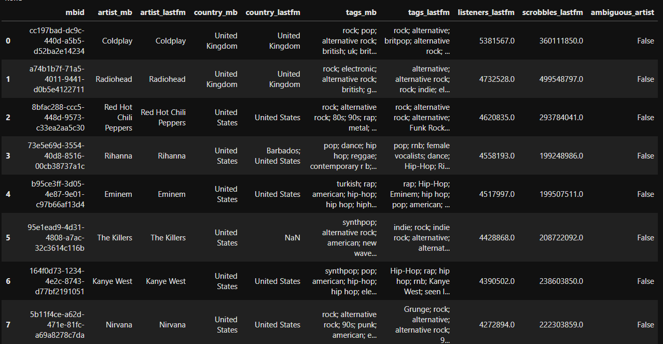

Billboard data

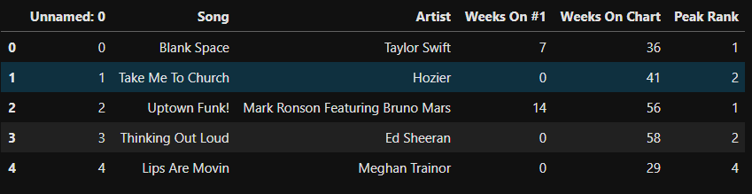

Spotify data

